Procedures for Safe Use of Pyrophoric Reagents

I. Introduction

In December 2008, a laboratory accident at UCLA occurred while the researcher was working with t-butyl lithium, a highly pyrophoric agent. Pyrophoric materials ignite spontaneously on contact with air; these chemicals react with oxygen, moisture in the air, or both. Failure to follow proper handling procedures can result in fire or explosion, leading to serious injuries/death or significant damage to facilities. Good technical guidance can be found in Aldrich Technical Bulletins AL-134 and AL-164 (http://www.sigmaaldrich.com/chemistry/aldrich-chemistry/tech-bulletins.html)

Below are some procedures describing the hazards, proper handling, disposal and emergency procedures when working with pyrophoric materials.

II. Examples of Pyrophoric Materials
Grignard Reagents: RMgX (R=alkyl, X=halogen)
Metal alkyls and aryls: Alkyl lithium compounds; tert-butyl lithium
Metal carbonyls: Lithium carbonyl, nickel tetracarbonyl
Metal powders (finely divided): Cobalt, iron, zinc, zirconium
Metal hydrides: Sodium hydride
Nonmetal hydrides: Diethylarsine, diethylphosphine
Non-metal alkyls: R₃B, R₃P, R₃As; tetramethyl silane, tributyl phosphine
Phosphorus
Potassium
Sodium
Gases: Silane, dichlorosilane, diborane, phosphine, arsine

A more extensive list of pyrophoric compounds can be found in Bretherick's Handbook of Reactive Chemical Hazards

III. Hazards
Pyrophorics must be handled under inert atmospheres and in such a way that rigorously excludes air/moisture since they ignite on contact with air and/or water. They all tend to be toxic and many come dissolved in a flammable solvent. Other common hazards include corrosivity, teratogenicity, water reactivity, peroxide formation, along with damage to the liver, kidneys, and central nervous system. Be especially vigilant when working tertiary butyl lithium which is extremely pyrophoric. Researchers working with pyrophoric materials must be proficient and must not work alone!

IV. Controlling the Hazards
BEFORE working with pyrophoric reagents, users must:
- Consult with your PI and confirm that approval has been received when working with highly hazardous materials.
- Read the relevant Material Safety Data Sheets (MSDS), technical bulletins, and guidance documents to understand and how to mitigate the hazards. The MSDS must be reviewed before using an unfamiliar chemical and periodically as a reminder.
- Prepare a written Standard Operating Procedure (SOP) identifying the safety precautions specific to the operations (http://www.ehs.uci.edu/labres.html )
  - Consider performing a “dry run” to identify and resolve possible hazards before conducting the actual procedure.
  - Users of pyrophoric materials must be trained in proper lab technique and be able to demonstrate proficiency.
  - Use less toxic or hazardous substances in your experiment and minimize the amount of hazardous waste generated.
- Perform a hazard analysis and identify the failure modes in your experiment. Be prepared to handle accidents.
- Know the location of eyewash/ shower, fire extinguishers, fire alarm pulls, and emergency exits.
- Complete required EH&S safety training requirements (www.ted.uci.edu) and lab specific training. Address all Safety on site (SOS) issues.
- Use the buddy system. Do not work alone or off hours where there are few people around to help
- Wear the appropriate personal protective equipment.
  - Use a lab coat, goggles/face shield and gloves.
- Maintain good work practices.
  - keep combustible materials, including paper towels and Kimwipes, away from pyrophoric reagents.
  - minimize the quantity of pyrophoric reagents used and stored and use the smallest quantity of material practical. It is better to do multiple transfers of small volumes than attempt to handle larger quantities. Consider using the cannula method when transferring more than 20 ml.
  - remove all excess and nonessential chemicals and equipment from the fume hood or glove box where pyrophoric chemicals will be used to minimize the risk of fire.
  - designate a fume hood or glove box for hazardous work.

A. Personal Protective Equipment (PPE)

Eye Protection
- Chemical splash goggles or safety glasses that meet the ANSI Z.87.1 1989 standard must be worn whenever handling pyrophoric chemicals. Ordinary prescription eye glasses will NOT provide adequate protection unless they also meet this standard. When there is the potential for splashes, goggles must be worn, and when appropriate, a face shield added.
- A face shield, worn over safety eyewear, is required any time there is a risk of explosion, large splash hazard or a highly exothermic reaction. All manipulations of pyrophoric chemicals which pose this risk should occur in a fume hood with the sash in the lowest feasible position. Portable shields, clamped to the counter top, may be used if fume hood space is not available.

Skin Protection
- Gloves must be worn when handling pyrophoric chemicals. Nomex pilot gloves should be used for handling these chemicals. Be sure to use adequate protection to prevent skin exposures. Sigma-Aldrich recommends the use of nitrile gloves underneath neoprene gloves.
- A lab coat made from Nomex is recommended for labs using these reagents routinely. Lab coats need to be buttoned and fit properly to cover as much skin as possible.
- Appropriate shoes, that cover the entire foot (closed toe, closed heel, no holes in the top) must be worn.

B. Safety Equipment

Have the proper equipment and the emergency phone number (9-1-1) readily available for any emergencies. The recommended fire extinguisher is a standard dry powder (ABC) type.

DO NOT use a carbon dioxide fire extinguisher or water to attempt to extinguish a pyrophoric material fire as these types of extinguishers can actually enhance the combustion of some pyrophoric materials. A small beaker of dry sand or soda ash (lime) in the work area is useful to extinguish any small fire that occurs at the syringe tip and to receive any last drops of reagent from the syringe.

Eyewash/ Safety Shower
- A combination eyewash/safety shower should be within 10 seconds travel time where pyrophoric chemicals are used. Inside the laboratory is optimum. Bottle type eyewash stations are not acceptable.

Fume Hood
- Verify that your fume hood has been checked in the last 12 months. Many pyrophoric chemicals release noxious or flammable gases, and some pyrophoric materials are stored under kerosene. These materials must be handled in a laboratory hood.

Glove (dry) box
- Glove boxes are an excellent device to control pyrophoric chemicals when inert or dry atmospheres are required.

Gas Cabinets
- Storage of pyrophoric gases is described in the California Fire Code, Chapter 41. Gas cabinets, with appropriate remote sensors and fire suppression equipment, are required.
- Gas flow, purge and exhaust systems should have redundant controls to prevent pyrophoric gas from igniting or exploding. All pyrophoric gases must have Restricted Flow Orifices (RFO) installed on the cylinder. Contact your gas supplier for assistance.
- Emergency back-up power should be provided for all electrical controls, alarms and safeguards associated with the pyrophoric gas storage and process systems.

V. Storage and Disposal

Storage

Some Pyrophoric materials cannot be stored in unsprinklered buildings; check list of restricted chemicals at: http://www.ehs.uci.edu/programs/fire/ChemicalsNotPermittedInUnsprinkleredBuildings.pdf

- Use and store minimal amounts of pyrophoric chemicals.
- Do not store pyrophoric chemicals with flammable materials or in a flammable liquids storage cabinet. Containers carrying pyrophoric materials must be clearly labeled with the correct chemical name, in English, and hazard warning.
- Store as recommended in the MSDS. A nitrogen-filled desiccator or glove box are suitable storage locations.
- If pyrophoric reagents are received in a specially designed shipping, storage or dispensing container, (such as the Aldrich Sure/Seal packaging system) ensure that the integrity of that container is maintained.
- Ensure that sufficient protective solvent, oil, kerosene, or inert gas remains in the container while the material is stored.
- NEVER return excess chemical to the original container. Small amounts of impurities introduced into the container may cause a fire or explosion.
- For storage of excess chemical, prepare a storage vessel in the following manner:
  - Select a septum that fits snugly into the neck of the vessel
  - Dry any new empty containers thoroughly
  - Insert septum into neck in a way that prevents atmosphere from entering the clean dry (or reagent filled) flask.
  - Insert a needle to vent the flask and quickly inject inert gas through a second needle to maintain a blanket of dry inert gas above the reactive reagent.
  - Once the vessel is fully purged with inert gas, remove the vent needle then the gas line.
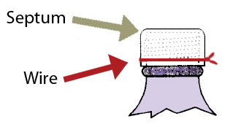
Fig. 1A Septum wired to vessel
- For long-term storage, the septum should be secured with a copper wire (figure 1A).
- For extra protection a second same-sized septa (sans holes) can be placed over the first (figure 1b).
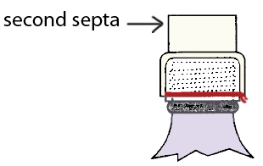
Fig. 1B For long-term
storage, use a second septum
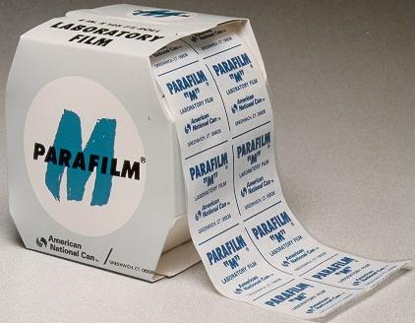
- Use parafilm around the outer septa and (obviously) remove the parafilm and outer septum before accessing the reagent through the primary septum³.

Disposal of Pyrophoric Reagents
- A container with any residue of pyrophoric materials should never be left open to the atmosphere.
- Any unused or unwanted pyrophoric materials must be destroyed by transferring the materials to an appropriate reaction flask for hydrolysis and/or neutralization with adequate cooling⁴.
- The essentially empty container should be rinsed three times with an inert dry solvent; this rinse solvent must also be neutralized or hydrolyzed. The rinse solvent must be added to and removed from the container under an inert atmosphere.
- After the container is triple-rinsed, it should be left open in back of a hood or ambient atmosphere at a safe location for at least a week. After the week, the container should then be triple rinsed again.
- The empty container, solvent rinses and water rinse should be disposed as hazardous waste.

Disposal of Pyrophoric Contaminated Materials
- All materials that are contaminated with pyrophoric chemicals should be disposed as hazardous waste. Proper and complete hazardous waste labeling of containers is vital.
- Alert EH&S for any wastes contaminated by pyrophoric chemicals.
- The contaminated waste should not be left overnight in the open laboratory but must be properly contained to prevent fires.

Important Steps to Follow
Pyrophoric reagents can be handled and stored safely as long as all exposure to atmospheric oxygen and moisture is avoided. Finely divided solids must be transferred under an inert atmosphere in a glove box. Liquids may be safely transferred without the use of a glove box by employing techniques and equipment discussed in the Aldrich Technical Information Bulletin AL-134. Pyrophoric gases should be handled in compliance with the California Fire Code, Chapter 41.

Handling Pyrophoric Liquids
- Users should read and understand the Aldrich Technical Information Bulletin No. AL-134. The PI should also have in place laboratory-specific handling, storage, and disposal standard operating procedures. The standard operating procedures should be included in the lab Chemical Hygiene Plan.
- By using proper syringe techniques, these reagents can be handled safely in the laboratory. The Aldrich Sure/Seal™ Packaging System provides a convenient method for storing and dispensing air-sensitive reagents.
- The reagent can be dispensed using a syringe or double-tipped needle (16, 18 or 20 gauge) inserted through the hole in the metal cap, as shown in fig. 2 below. It is recommended that the plastic cap be replaced after each use and in particular for long-term storage.

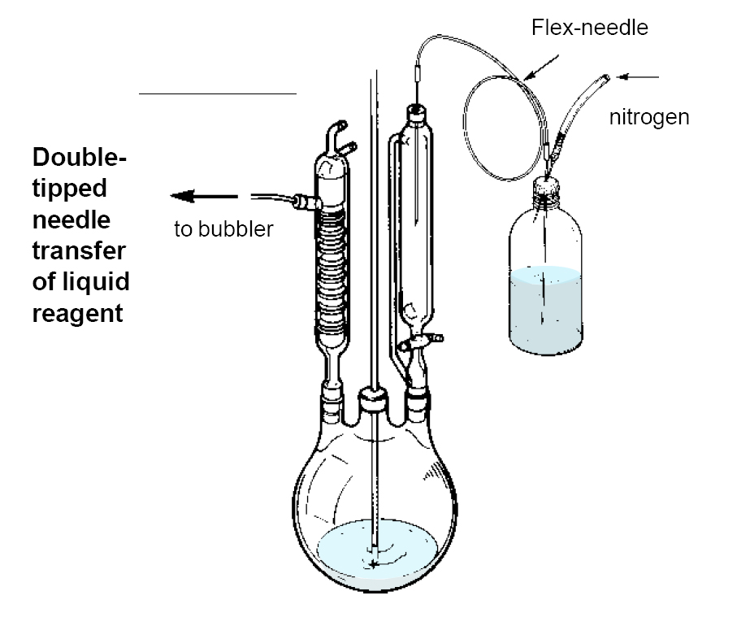
Fig. 2 Double-tipped needle transfer of liquid reagent

- For extended storage of unused reagents, use the solid plastic cap, or equip the bottle with an Oxford Sure/Seal valve cap, or transfer the reagent to a suitable storage vessel, as described above.

Emergency Procedures

Spill
- Powdered lime should be used to completely smother and cover any spill that occurs.
- DO NOT use water to attempt to extinguish a pyrophoric material fire as it can actually enhance the combustion of some pyrophoric materials, e.g. metal compounds.
- Do not use combustible materials (paper towels) to clean up a spill, as these may increase the risk of igniting the pyrophoric compound. Soda ash (powdered lime) or dry sand should be used to completely smother and cover any small spill that occurs.
- A container of powdered lime should be kept within arm’s length when working with a pyrophoric material.
- If anyone is exposed, or on fire, wash body with copious amounts of water.
- The recommended fire extinguisher is a standard dry powder (ABC) type. Class D extinguishers are recommended for combustible solid metal fires (e.g, sodium, LAH), but not for organolithium reagents.
- Call 9-1-1 for emergency assistance

Excerpt from the Sigma-Aldrich Technical Bulletins AL-134 and AL-164 at: http://www.sigmaaldrich.com/chemistry/aldrich-chemistry/tech-bulletins/tech-bulletin-numbers.html

The Aldrich Sure/Seal™ Packaging System
Fig. 1A Sure/Seal components
The Sure/Seal packaging system (Fig. 1A) provides a convenient method for storing and dispensing air-sensitive reagents. The reagent can be dispensed using a syringe or double-tipped needle (16, 18 or 20 gauge) inserted through the hole in the metal cap. When inserting a needle through a septum, a layer of silicone or hydrocarbon grease on the septum will help. Upon withdrawal of the needle, the small hole that remains in the PTFE liner will not cause the reagent to deteriorate under normal circumstances. However, it is recommended that the plastic cap be replaced after each use and in particular for long-term storage.
Fig. 1B Sure/Seal septum-inlet transfer adapter

For extended storage of unused reagents, use the solid plastic cap, or equip the bottle with an Oxford Sure/Seal valve cap, or transfer the reagent to a suitable storage vessel.

The Sure/Seal septum-inlet transfer adapter (Fig. 1B) can be used when repeated dispensing is necessary. The adapter protects the contents of the bottles from air and moisture.
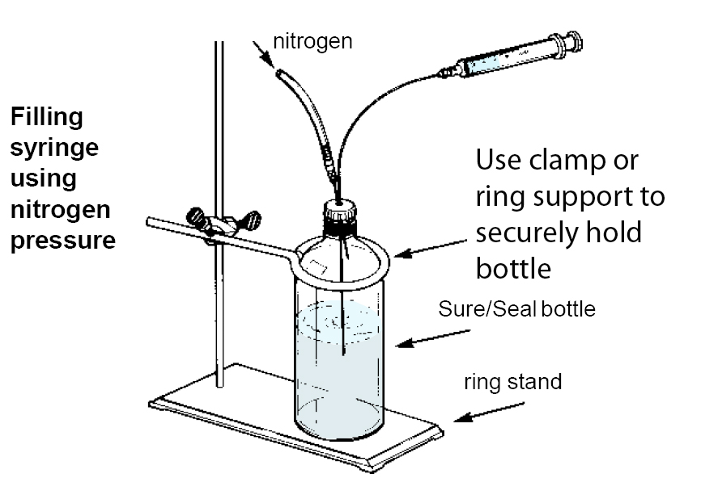
Fig. 2A Filling syringe using nitrogen pressure

Transferring Pyrophoric Reagents with Syringe
- In a fume hood or glove box, clamp the reagent bottle to prevent it from moving
- Clamp/secure the receiving vessel too.
- After flushing the syringe with inert gas, depress the plunger and insert the syringe into the Sure/Seal bottle with the tip of the needle below the level of the liquid
- Secure the syringe so if the plunger blows out of the body it, and the contents will not impact anyone (aim it toward the back of the containment)
- Insert a needle from an inert gas source carefully keeping the tip of the needle above the level of the liquid
- Gently open the inert gas flow control valve to slowly add nitrogen gas into the Sure/Seal bottle.
- This will allow the liquid to slowly fill the syringe (up to 100mL) as shown in Fig. 2A. Pulling the plunger causes gas bubbles.
- Let nitrogen pressure push the plunger to reduce bubbles. Excess reagent and entrained bubbles are then forced back into the reagent bottle as shown in Fig. 2B.
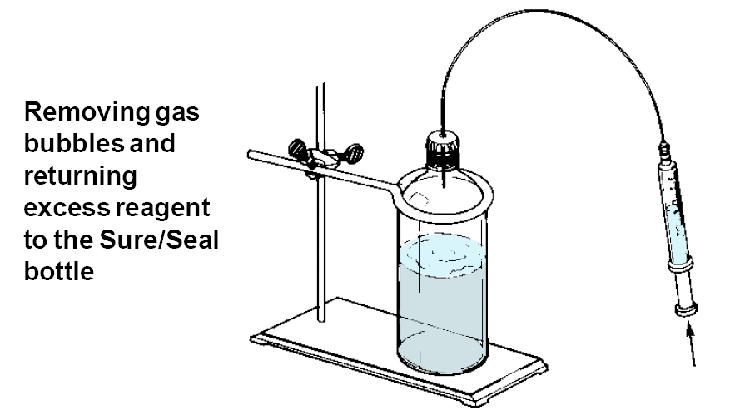
Fig. 2B Removing gas bubbles and returning excess reagent
to the Sure/Seal bottle
- The desired volume of reagent in the syringe is quickly transferred to the reaction apparatus by puncturing a rubber septum as illustrated in Fig. 2C.
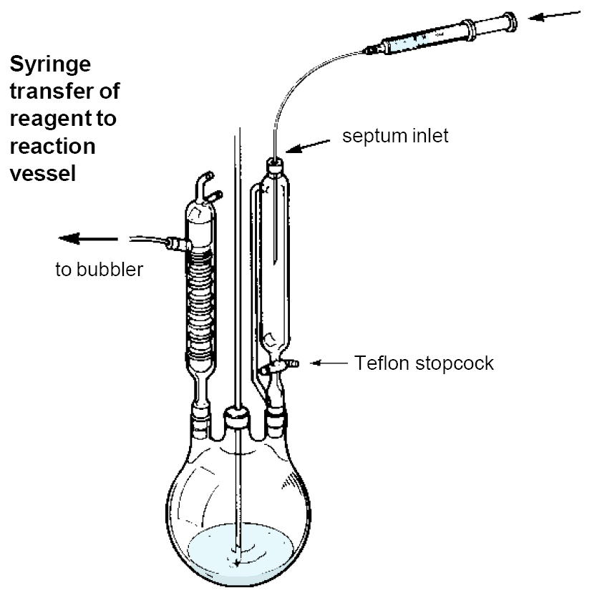
Fig. 2C Syringe transfer of reagent to reaction vessel

Fig. 3A Double-tipped needle transfer of liquid reagent

Transferring Pyrophoric Reagents with a Double-Tipped Needle (Cannula)
- The double-tipped needle technique is recommended when transferring 50 mL or more.
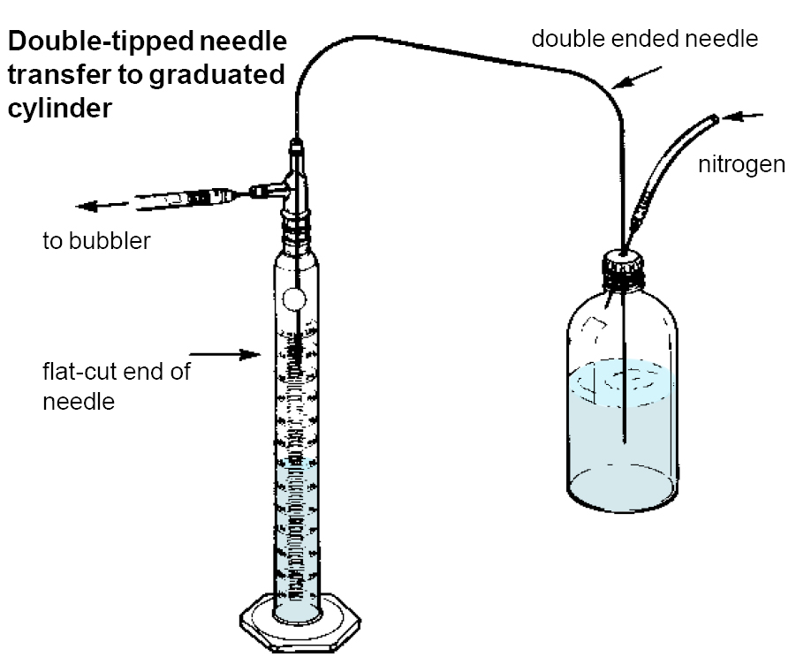
Fig. 3B Double-tipped needle transfer to graduated cylinder
- Pressurize the Sure/Seal bottle with nitrogen and then insert the double-tipped needle through the septum into the headspace above the reagent. Nitrogen will pass through the needle. Insert the other end through the septum at the calibrated addition funnel on the reaction apparatus. Push the needle into the liquid in the Sure/Seal reagent bottle and transfer the desired volume. Then withdraw the needle to above the liquid level. Allow nitrogen to flush the needle. Remove the needle first from the reaction apparatus and then from the reagent bottle. (Fig. 3A)
- For an exact measured transfer, convey from the Sure/Seal bottle to a dry nitrogen flushed graduated cylinder fitted with a double-inlet adapter (Fig. 3B). Transfer the desired quantity and then remove the needle from the Sure/Seal bottle and insert it through the septum on the reaction apparatus. Apply nitrogen pressure as before and the measured quantity of reagent is added to the reaction flask.
- To control flow rate, fit a Luer lock syringe valve between two long needles as shown in (Fig. 3C).
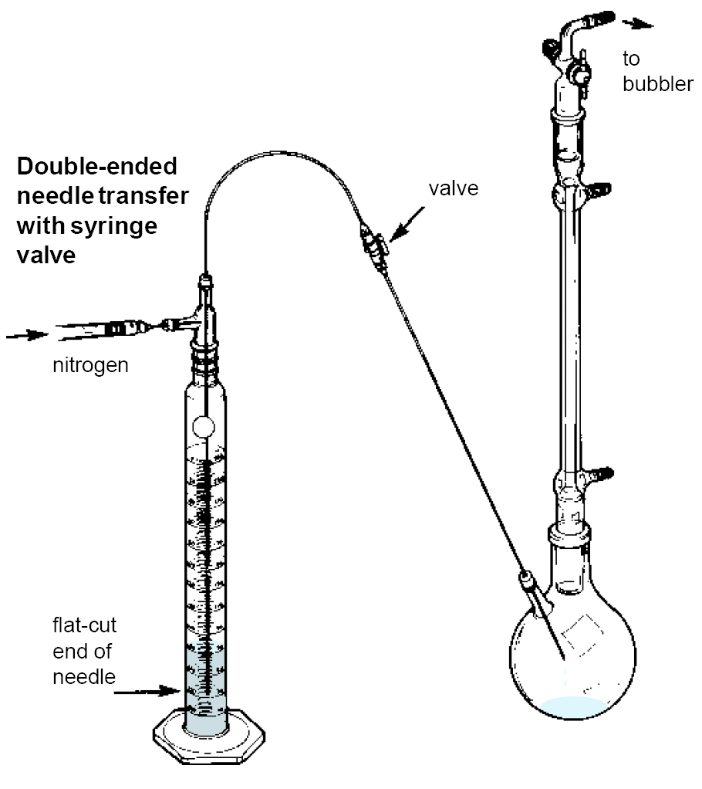
Fig. 3C Double-ended needle transfer with syringe valve

Created from a variety of resources, principally the Sigma-Aldrich Technical Bulletins AL-134 and AL-164 at: http://www.sigmaaldrich.com/chemistry/aldrich-chemistry/tech-bulletins/tech-bulletin-numbers.html
Private communication to Rebecca Lally (rrlally@uci.edu) at UC Irvine in January 2009
Images and advice from Sigma-Aldrich Technical Bulletins ⁴ Destruction of Hazardous Chemicals in the Laboratory ,George Lunn, Eric B. Sansone ,Wiley-Interscience; 2nd edition (March 1994) , ISBN: 047157399X Additional References: Leonard J., B. Lygo, and G. Procter, Advanced practical organic chemistry. London : Blackie ; New York : Chapman and Hall, 1995, pages 76-98. Prudent Practices in the Laboratory: Handling and Disposal of Chemicals , National Research Council Publisher: National Academies Press; 1 edition (January 10, 2000), ISBN: 0309052297 We wish to acknowledge the following sources: Brandeis University, Standard Operating Procedure for Pyorphoric Chemicals; University of Nebraska, Lincoln, Pyrophoric Chemicals Standard Operating Procedure; University of Pittsburgh Safety Manual, Flammable and Pyrophoric Gas; Rochester University, SOP for Pyrophoric Chemicals. Personal communication with(and grateful acknowledgement to) Dr. Russell Vernon, Environmental Health and Safety, UC, Riverside; Dr. Joseph Pickel, Center for Nanophase Materials Sciences, Oak Ridge National Laboratory; Dr. Neal Langerman, Principal, Advanced Chemical Safety, Inc.; Dr. Frank Osterloh, Professor of Chemistry, UC Davis. Grateful acknowledgement to Russell Vernon (russell.vernon@ucr.edu), Debbie Decker, (dmdecker@ucdavis.edu) and the UC Lab Safety Workgroup. These safety training resources, prepared solely for the use of the Regents of the University of California, were provided by a variety of sources. It is your responsibility to customize the information to match your specific operations. Neither the University of California nor any of its employees, makes any warranty, express or implied, or assumes any legal liability or responsibility for the accuracy, completeness, or usefulness of any information, or represents that its use would not infringe privately owned rights. Reference herein to any specific commercial product, process, or service by trade name, trademark, manufacturer, or otherwise, does not necessarily constitute or imply its endorsement, recommendation, or favoring by the University of California. The views and opinions of authors expressed herein do not necessarily state or reflect those of the University of California, and shall not be used for advertising or product endorsement purposes.

